

Department of Communication and Network Engineering
FYP595: Final Year Project I
Spring 2026
Smart University Mobile Application Integrated with IOT-Based Campus Services
 | Name | Email | Phone
Submitted by | Mr. Khaled Othman | 202110142@st.cityu.edu.lb | +961 81 499 070
Supervisor | Dr. Bassel EL Haj | b.hajj@cityu.edu.lb | +961 71 512 700
1st Examiner | Eng. Ihab Hassoun | i.hassoun@cityu.edu.lb | +961 71 401 618
2nd Examiner | Mr. Jamal Taftafa | jamalt@nicgroup.com | +961 03 691 553
Faculty Dean | Dr. Hiba Al Sheikh | h.sheikh@cityu.edu.lb | +961 03 171 847

Abstract
Universities are increasingly adopting smart technologies to improve campus services, communication efficiency, and operational management. However, many educational institutions still depend on traditional systems that consume time, reduce efficiency, and create unnecessary difficulties for students, instructors, staff members, and visitors. Common challenges include manual attendance procedures, parking congestion, difficulty navigating university facilities, and limited visitor assistance services.
This project presents the design of a Smart University Mobile Application that integrates multiple smart campus services into one centralized platform. The proposed system combines mobile technologies, Internet of Things (IOT) devices, cloud services to support intelligent campus operations.
The proposed application includes four main services: a QR-code-based Smart Attendance System, a Smart Parking System for real-time parking monitoring, a Smart Navigation System for indoor and outdoor campus guidance, and a Guest and Search System that assists users in locating university offices, buildings, and facilities.
The current phase of the project focuses on system analysis, architecture planning, workflow development, database design, and mobile application prototype development.
The proposed solution aims to simplify university services, reduce manual procedures, improve communication efficiency, and support digital transformation within smart educational environments.
The project demonstrates how integrating smart technologies into a unified mobile platform can improve campus management and provide a scalable foundation for future smart university systems.

Keywords: Internet of Things (IOT), Smart University, cloud services.

Table of Contents
Abstract i
Table of Contents ii
List of Figures iv
List of Tables v
List of Abbreviations vi
Acknowledgements vii
Chapter 1: Introduction 1
1.1 Background 2
1.2 Statement of the problem 3
1.3 Purposes 3
1.4 Significance, Scope and Definitions 4
1.4.1 SIGNIFICANCE 4
1.4.2 SCOPE OF WORK 4
1.4.3 DEFINITION OF KEYS TERMS 4
1.5 Thesis Outline 5
Chapter 2: Literature Review 7
2.1 Historical Background 7
2.2 Internet of Things (IoT) Higher Education 8
2.3 QR-Code-Based Smart Attendance System 10
2.4 IoT-Based Smart Parking System 11
2.5 Smart Campus- Carolina Del-Valle-Soto 13
2.5.1 Wireless Communication Networks 14
2.5.2 What Protocols Did They Test? 15
2.5.3 Collaborative vs. Cooperative – What is the Difference? 16
2.5.4 Results Under the Cooperative Scheme 16
2.6 Comparison and Conclusions 17
2.6.1 Discussion and Conclusion 19
Chapter 3: Project Design 21
3.1 System overview 22
3.2 Smart Services Design 23
3.2.1 Smart Attendance System (QR-Code Based) 23
3.2.2 Smart Parking System 26
3.2.3 Smart Navigation System 29
3.2.4 Guest and Search System 30
3.3 System Components and Design Decisions 31
3.4 Database Design 31
3.5 Mobile Application Design 32
3.5.1 User Roles and Access Levels 32
3.5.2 Mobile Application Screens 33
3.5.3 Service Integration Design 34
3.6 Conclusion 34
Chapter 4: Methodology 35
4.1 Research Design 36
4.2 Problem Requirements 38
4.3 Mobile Application Development Methodology 40
4.3.1 Flutter Development Environment 40
4.3.2 Firebase Connection Method 40
4.4 Dataset Collection and Preparation 41
4.4.1 Smart Attendance Dataset 41
4.4.2 Smart Parking Dataset 42
4.4.3 Navigation Dataset 42
4.4.4 Guest and Search Dataset 42
4.5 Project Constraints 43
4.6 Proposing Possible Solutions 44
4.6.1 Solution 1: Mobile Application Integrated with Four services 44
4.7 Selecting the Best Solution 44
4.8 Instruments 45
4.9 Procedure and Timeline 46
4.10 Analysis 47
4.11 Conclusion 48
Chapter 5: Results and Discussions 49
Chapter 6: Project Management 51
6.1 Schedule of Tasks and Gantt Chart 51
6.2 SWOT Analysis 51
6.3 Expected Budget 51
6.4 Students’ Responsibilities and Contribution 51
Chapter 7: Conclusions and Future Works 52
References 53
Appendices 54

List of Figures
Figure 1: Smart Education Environment [1]. 9
Figure 2: four-tiered smart parking system with fog functionality [3]. 11
Figure 3: End-to-end latency[3]. 12
Figure 4: Concepts and aspects of Wireless Communication Networks [4]. 15
Figure 5: Network sensors under each technology [4]. 15
Figure 6: Smart University System Architectures. 22
Figure 7: Proposed Smart Attendance System using QR code technology [6]. 24
Figure 8: QR-Code Attendance Device. 25
Figure 9: Smart Attendance Architecture [7]. 26
Figure 10: Smart parking Architecture [8]. 27
Figure 11: Proposed prototype of smart parking sensors 28
Figure 12: Smart Navigation System Architecture 29
Figure 13: Guest and Search System Architecture [10]. 30
Figure 14: System integration. 34
Figure 15: Proposed Workflow of Methodology. 35
Figure 16: Gantt Chart . 51

List of Tables

Table 1:Specifications of the studied wireless technologies[4]. 15
Table 2:Nodes under the cooperative scheme[4]. 16
Table 3:Nodes under the collaborative scheme[4]. 16
Table 4 : Comparison of Studies. 17
Table 5:User Roles and Access Levels. 32
Table 6:Mobile Application Screens. 33
Table 7: Methodology Stage. 37
Table 8:Problem Requirements. 38
Table 9: Flutter development tools. 40
Table 10:Dataset about Smart Attendance. 41
Table 11:Dataset of Smart Parking System. 42
Table 12: Dataset for Navigation System. 42
Table 13:Dataset of Guest and Search System. 42
Table 14: Constraint. 43
Table 15: Tools and Instrument. 46
Table 16:Timeline & Procedure. 46

List of Abbreviations
API: Application Programming Interface.
BLE: Bluetooth Low Energy
GPS: Global Positioning System
UI: User Interface
IOT: Internet of Things
LORAWAN: Long Range Wide Area Network
MQTT: Message Queuing Telemetry Transport
QR: Quick Response-Code
RFID: Radio Frequency Identification
SQL: Structured Query Language

Acknowledgements
First and foremost, I want to thank my project supervisor, Dr. Bassel EL Haj, for his invaluable guidance, immense patience, and constant encouragement throughout the formulation and development of this project. His profound technical expertise in advanced networking systems, constructive feedback, and insightful recommendations not only shaped the engineering direction of this work but also significantly enhanced my academic and research capabilities.
I would also like to extend my sincere thanks to the faculty and staff of the Department of Communication and Network Engineering at City University for providing the rigorous academic foundation, modern resources, and supportive environment necessary to execute this work successfully. I am equally grateful to the members of my examination committee, Eng. Ihab Hassoun and Mr. Jamal Taftafa , as well as the Faculty Dean, Dr. Hiba Al Sheikh, for their valuable time, meticulous evaluation, and crucial suggestions during the review and defense process.
On a personal note, I owe an immense debt of gratitude to my family for their unwavering support, endless sacrifices, and continuous encouragement. Their absolute belief in my potential has been a constant source of motivation and strength during the most demanding phases of my academic journey and final year project.
Finally, I would like to thank my peers, friends, and everyone who contributed directly or indirectly to the realization of this work. Your encouragement, shared insights, and camaraderie made this challenging academic milestone a deeply rewarding and memorable experience.

Introduction
The rapid development of digital technologies has encouraged universities to adopt smart systems capable of improving educational services, communication efficiency, and campus management. Modern universities are increasingly moving toward smart campus environments that support automation, centralized management, real-time monitoring, and intelligent service integration.
A smart university uses technology to make academic and administrative services faster, more accurate, and easier to access for students, instructors, staff members, and visitors.
Many campus services are still handled manually. Attendance may be recorded using paper sheets or manual roll calls, parking availability is usually not visible before students arrive, and new students or visitors may need to ask several people before finding an office, classroom, or facility. These issues waste time and reduce the quality of the campus experience.
The Internet of Things (IOT) refers to interconnected smart devices and sensors capable of collecting and exchanging information through communication networks [1]. IOT technologies allow universities to monitor parking spaces, classroom activities, environmental conditions, and campus facilities in real time.
Despite recent technological advancements, many universities still depend on traditional systems for attendance management, parking organization, campus navigation, and visitor support services. Manual attendance procedures consume lecture time and may allow inaccurate attendance records. Parking congestion creates delays during busy academic hours, while large university campuses may be difficult to navigate for new students and visitors unfamiliar with campus facilities.
To address these challenges, this project proposes the design of a Smart University Mobile Application that integrates multiple smart services into one centralized platform. The proposed system combines mobile technologies, IOT, cloud services and smart communication infrastructure to improve campus operations and enhance user experience.
The proposed application includes four main services:
- Smart Attendance System
- Smart Parking System
- Smart Navigation System
- Guest and Search System
This chapter outlines the background (section ‎1.1) and context of the research, and its purposes (section ‎1.3). Section ‎1.4 describes the significance and scope of this research and provides definitions of terms used. Finally, section ‎1.5 includes an outline of the remaining chapters of the thesis.

Background
In recent years, universities have started using more technology to improve education and campus life. This concept is known as a "smart university". A smart university uses modern systems to make services faster, easier, and more efficient for students and staff like (SIS, Online Teaching).
With the development of IOT, many devices can now be connected to the internet. These devices include sensors, cameras, and air conditioning systems. For example, sensors can detect if a classroom is full or if a parking space is available.
In this project, IOT technology is mainly used in the parking service, where sensors detect whether a parking space is available or occupied. Cloud services are used to store and synchronize data between the mobile application, the instructor dashboard, and the administrator interface. The mobile application is the main user interface for students and guests.
The attendance service is designed around QR-code technology. During a class session, the instructor generates a unique QR code. Students log in to the mobile application and scan the QR code using the phone camera. The system then stores the attendance record in the cloud database with the student ID, course ID, session ID, date, and time. This method is faster than manual attendance and reduces hardware cost, and makes the system easier to deploy.

Statement of the problem
Based on interviews conducted with university students and instructors, several common problems were identified inside the university environment.
First use of manual attendance methods, which consume lecture time and may allow fake attendance submissions. Second Parking congestion inside university campuses also creates delays and traffic problems, especially during busy academic hours. Third students and visitors often experience difficulty locating classrooms, laboratories, and staff offices in large university campuses. Traditional visitor support systems also rely heavily on manual assistance and information desks, which may reduce service efficiency. Although previous studies proposed several smart campus solutions, most existing systems focus on individual services separately rather than providing a centralized platform that integrates multiple smart services into one unified system. Therefore, there is a need for a smart university platform capable of integrating attendance management, parking monitoring, navigation assistance, and guest services into a single mobile application supported by intelligent technologies such as IOT, and cloud computing.
The proposed platform can be supported by modern technologies such as IOT devices, cloud services, and intelligent software modules to enable real-time data collection, processing, and service delivery.

Purposes
The main purpose of this project is to design a Smart University Mobile Application based on IOT to serve students and users to:
Objective 1: Develop smart attendance.
Objective 2: Implement Smart Systems parking availability.
Objective 3: Implement a Smart Navigation System.
Objective 4: Develop a guest and search assistance service.

Significance, Scope and Definitions

SIGNIFICANCE
This project is significant because it provides a practical solution to daily university problems using a unified mobile application. The QR-code attendance system can reduce the time spent on manual roll calls and improve the organization of attendance records. The parking service can help students save time by showing available parking spaces before or during arrival. The navigation and guest/search services can improve accessibility for new students, visitors, and staff members.
The project also provides a useful blueprint for future implementation because it identifies the required application modules, database structure, hardware components for parking, and workflow of each service. It is suitable for a final year project because it combines software development, IOT integration, database design, and user interface design.

SCOPE OF WORK
- Mobile application interfaces
- Implementation of four specific campus services:
- Smart attendance link to main SIS, and managed by a dashboard
- Smart parking (available spot detection and guidance)
- Smart navigation assistance
- Guest and search services

DEFINITION OF KEYS TERMS
Internet of Things (IOT): A network of physical devices (sensors, cameras, smart lights, RFID readers) that collect data and send it over the internet without human intervention. In my project, IOT devices for search parking availability the smart campus.
QR-Code: A machine-readable code used for storing information that can be scanned using smartphones.
Mobile Application: A single web-based interface that shows all campus resources and their status in real time. For example, the dashboard would show which classrooms are occupied which parking spots are free.
Cloud Database: An online database used to store and synchronize information between the mobile application, dashboard, and IOT devices.

Thesis Outline
This thesis is organized into seven chapters. Here is a brief description of what each chapter contains. This outline helps the reader understand the flow of the work.
Chapter 1: Introduction (this chapter) – introduced the background of smart universities and why they matter, describing the problem, explained the purposes and four specific objectives of the project. Discussed why this research is significant, defined the scope, and provided clear definitions of key terms. Finally, give this outline of the remaining chapters.
Chapter 2: Literature Review – will review existing research papers on four main topics: IOT in higher education, Qr-code smart attendance system, IOT-based smart parking system, and experimental comparisons of wireless sensor network protocols. For each paper, explain the methodology, key findings, and limitations. At the end of the chapter, present a comparison table of all the study, identify the research gaps, and explain how my project fills those gaps.
Chapter 3: Project Design –present the complete design of my proposed smart university system. This includes the system architecture with layers explain the design of the four smart services: smart attendance using QR codes, smart parking management using ultrasonic sensors, smart navigation using GPS for Outdoor navigation and guest and search system. Will also show the mobile application design, the centralized dashboard for administrators and instructors, and the database design that connects all services together.
Chapter 4: Methodology - explain the methodology used to develop and evaluate the proposed system. This includes the research design, problem requirements, and dataset collection for each of the four services, project constraints. I will also list all instruments and tools used, including mobile app development tools Android Studio, database tools Firebase. Finally, I will explain the procedure, timeline, and analysis methods.

Chapter 5: Results and Discussions – I will present the results from my mobile application and dashboard testing. This includes attendance verification accuracy, parking detection response time, navigation route generation time, search result accuracy, and user interface usability. I will present these results in tables and charts. Then I will discuss what these numbers mean, how they compare to the literature, and whether the proposed system successfully solved the identified problems.
Chapter 6: Project Management – Show Gantt chart with the complete schedule of tasks from Week 1 to Week 15 of the Spring 2026 semester. I will present a SWOT analysis (Strengths, Weaknesses, Opportunities, and Threats) of my project to show that I have thought carefully about risks and challenges. An expected budget table showing what it would cost if this system were to be deployed in a real university. Finally, I will explain my responsibilities as the sole student working on this project.
Chapter 7: Conclusions and Future Works – I will summarize everything I have done in the project. I will state my main conclusions: what worked well, what did not work, and what I learned. I will discuss the limitations of my project (what I could not do due to time, budget, or other constraints). Finally, I will make recommendations for future researchers who want to extend this work. For example, future work could include adding security features, deploying on a real campus, implementing a digital twin, or developing a mobile app for students.

Literature Review
Recent technological advancements have encouraged universities to adopt smart systems capable of improving campus management, communication efficiency and educational services. Smart campus technologies integrate communication systems, IOT devices, mobile applications, cloud services and intelligent data processing to provide efficient and automated university environments.
Several studies highlighted the importance of integrating Internet of Things (IOT), and centralized communication infrastructures into educational environments to improve operational efficiency.
This chapter reviews previous studies related to smart universities, IOT applications and intelligent campus services relevant to the proposed Smart University Mobile Application.
This chapter begins with a historical background of smart campus evolution and reviews literature on the following topics: the role of the Internet of Things (IOT) in higher education (Section 2.2); Qr-Code smart attendance system (Section 2.3); IOT-based smart parking system (Section 2.4); and wireless sensor network performance comparison of collaborative and cooperative schemes (Section 2.5). Section 2.6 provides a comparison and critical evaluation of the reviewed studies, highlighting the research gaps that this project aims to address.

Historical Background
Smart campuses are not a new idea. People have been trying to make universities "smart" for about twenty years. But back in the early 2000s, it was very basic. You might have a card to open a door, or a digital library system, but nothing was connected together [5].
The evolution of smart universities has been driven by the need to integrate digital technologies into academic and administrative operations. Institutions have increasingly adopted IOT devices, mobile applications, and cloud services to automate campus functions such as attendance management, parking monitoring, and visitor guidance. However, the effectiveness of these services is fundamentally dependent on the underlying network infrastructure. A smart parking system that relies on real-time sensor data, or an attendance system that transmits QR-code scan records to a centralized server, cannot function reliably without a stable, low-latency communication network. This interdependency between smart services, ensuring that time-sensitive services such as attendance recording and parking updates are delivered without interruption. The integration of IOT and services into a Centralize Dashboard required to support a fully operational smart university environment.
Wireless sensor networks (WSNs) are a big part of this. We put small sensors around the campus. They measure things like temperature, how many people are in a room, or if a parking spot is free. These sensors send a lot of information.

Internet of Things (IoT) Higher Education
MARINELA MIRCEA et al. [1] wrote a paper in (2025) about IOT in higher education they wanted to know what factors affect how universities use IOT. They also wanted to see what research is out there about managing university resources with IOT. The Methodology used in this study is the Systematic Literature Review investigating the impact of IOT on higher education.
The review provides a comprehensive overview of existing smart campus technologies and highlights the main components required for building an intelligent university environment. The study demonstrates how IOT devices, cloud services, and smart applications can be integrated to improve campus operations and user experience.
IOT makes it easy to track things on campus in time like energy use, student attendance and how facilities are used which helps use them better. Also connected devices make things run smoothly.
This paper gives me good background. It shows that university are trying to use IOT The findings of this study helped identify important design considerations such as system scalability, service integration, data management, and communication reliability. These aspects were considered during the design of the proposed Smart University Mobile Application to ensure efficient delivery of attendance, parking, navigation, and guest services.
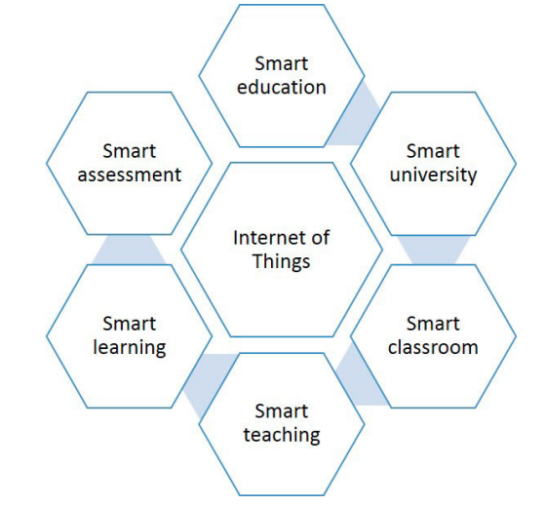
Figure 1: Smart Education Environment [1].

Figure 1 shows the Internet of Things helps make university campuses smarter. It allows devices communicate to each other collecting data in time and making smart decisions.
The figure illustrates the following:
- Smart education is about using tech to make the education system better.
- A smart university is one that uses automation to improve how it runs and manages resources.
- A smart classroom is a learning space with devices that connect to the internet.
- Smart teaching uses tools to help teaching to be better.
- Smart learning is about making learning fit each student needs and style.
- Smart assessment uses automated systems to check how well students are doing.
All these components rely on Internet of Things (IOT) technologies to collect, transmit, and process data across the campus environment. For example, sensors, RFID devices, smart meters, and monitoring systems continuously exchange information through connected networks to support campus services. However, the study does not provide detailed discussion regarding important challenges such as network scalability, data security, privacy protection, and system integration.
This study is relevant to the proposed project because it demonstrates how IOT technologies can support smart university services. The proposed Smart University Mobile Application also utilizes IOT devices, particularly in the Smart Attendance and Smart Parking services, to collect real-time information and improve service efficiency within the university environment.
The proposed Smart University Mobile Application utilizes IOT devices, cloud services, and intelligent software modules to provide integrated smart campus services
The Internet of Things is what makes campus systems work. People have been looking into using intelligence with the Internet of Things to make these systems work even better and make better decisions.
While the systematic review by MARINELA MIRCEA [1] provides a high-level understanding of how universities adopt new technology, it faces several constraints. Primarily, the study is focused on the organizational and pedagogical factors of adoption it does not provide a detailed engineering roadmap or specific networking architectures required to support a high density of IOT devices.
Furthermore, the reviewed studies do not provide sufficient discussion on integrated mobile applications that combine multiple smart university services within a single platform.

QR-Code-Based Smart Attendance System
Rohann et al. [2] (2026) presented an optimized QR-code-based authentication system for attendance management in academic institutions. The paper focused on the problem of inaccurate and unreliable attendance monitoring. Traditional attendance methods, such as manual attendance sheets, consume lecture time, increase the workload of instructors, and may include human errors. Some digital attendance systems also face problems because they are expensive to implement or can be misused when students share attendance cards or forward attendance links to others. These issues reduce the reliability of attendance records and create a need for a more secure and efficient attendance method.
To solve this problem, the study proposed a QR-code-based authentication system. The method depends on generating a QR code for attendance and allowing students to scan the code to confirm their presence. After the QR code is scanned, the system verifies the authentication process and stores the attendance record. The proposed method is designed to improve attendance accuracy and reduce fraudulent attendance practices without depending on expensive biometric hardware such as fingerprint scanners.
The main benefit of the QR-code-based system is that it makes attendance recording faster, easier, and more reliable. It reduces the time needed to record attendance manually and supports digital storage of attendance records. It is also suitable for universities because students can use mobile devices to scan QR codes, which makes the system practical and low-cost. In addition, the use of authentication improves the reliability of attendance monitoring compared with simple manual methods.
However, the paper also shows that QR-code attendance systems still have some limitations. One important limitation is the possibility of misuse if students share the QR code with classmates who are not physically present. Another limitation is that the system depends on students having a working mobile device and internet connection. For this reason, QR-code attendance should include extra validation steps such as a short QR-code expiry time, student login verification, session ID checking, and scan-time recording.

IoT-Based Smart Parking System
Mohammed Alaanzy et al. [3] present a real-time smart parking system based on the Internet of Things and fog computing (2025). The paper focused on the problem of parking congestion, wasted time and inefficient use of parking spaces. In many urban and institutional environments, drivers spend time searching manually for available parking spots. This increases traffic congestion, delays arrival time, wastes fuel, and contributes to environmental pollution. The study also explained that traditional parking systems do not provide real-time information about parking availability, which makes parking management inefficient.
To solve this problem, the authors proposed a smart parking system that uses IoT devices and fog computing to monitor parking availability in real time. The system uses cameras and edge devices to detect parking slot availability.
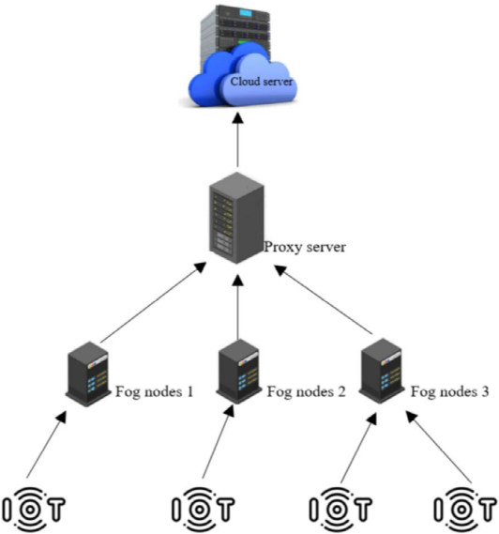
Figure 2: four-tiered smart parking system with fog functionality [3].

Figure 2 shows the four-tiered smart parking architecture proposed author. The system collects parking data through IOT devices, processes the data near the parking area using fog nodes, transfers selected information through a proxy server, and stores long-term data in the cloud. This architecture helps provide real-time parking availability updates and reduces delay compared with sending all data directly to the cloud.
The collected data is processed close to the parking area using fog nodes instead of sending all data directly to the cloud. This reduces delay and allows the system to provide faster updates about available parking spots. The architecture includes four main layers: data acquisition and edge processing, fog computing, proxy server, and cloud computing. Each layer has a specific role in collecting, processing, transferring, and storing parking information.
The study evaluated the proposed system using the iFogSim2 simulation toolkit and a practical case study at SDU University Park. The authors compared fog-based processing with cloud-based processing using several performance metrics, including end-to-end latency, execution cost, execution time, network usage, and energy consumption.
The results show that the fog-based system performed better than the cloud-based system. For example, the fog-based approach reduced latency and execution time because data was processed closer to the parking area. It also reduced network usage by avoiding the continuous transfer of large amounts of data to the cloud. These results show that IOT-based smart parking systems can improve responsiveness and help drivers find available spaces more efficiently.
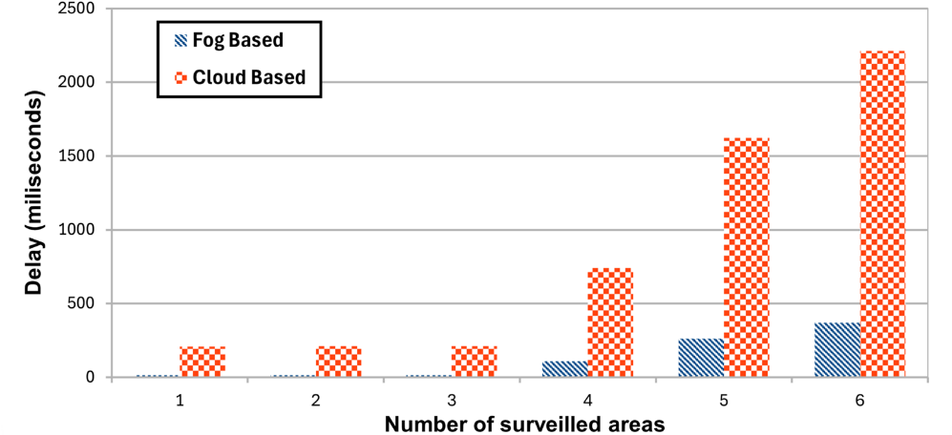
Figure 3: End-to-end latency[3].

Figure 3 presents the end-to-end latency comparison between fog-based and cloud-based architectures. The results show that the fog-based system provides lower delay than the cloud-based system because parking data is processed closer to the parking area. As the number of monitored areas increases, cloud-based latency increases sharply, while fog-based latency remains lower and more stable. This supports the importance of fast response time in smart parking systems.

The paper is useful for this project because the proposed Smart University Mobile Application also includes a smart parking service. In this project, the parking system will use IOT sensors, such as ultrasonic or IR sensors, to detect whether parking spaces are available or occupied. The sensor data will be collected by an ESP32 microcontroller and sent to the cloud database. The mobile application will then display the parking status to students, instructors, staff members, and visitors. Although the paper uses cameras and fog computing, while this project uses a simpler sensor-based prototype, both systems share the same goal: providing real-time parking availability to reduce time wasted searching for parking.
However, the paper also has some limitations when compared with this project. The proposed system in the paper is more complex because it depends on fog nodes, cameras, proxy servers, cloud servers, and simulation tools. This may require more hardware, stronger infrastructure, and higher implementation cost. In addition, the system was mainly evaluated using simulation and a specific university parking case study, so applying it to other campuses may require adjustment based on parking layout, network availability, and budget. For a final year project, a simpler prototype using ESP32 and ultrasonic or IR sensors is more practical and easier to implement.
This study supports the proposed project by providing academic evidence that IoT-based parking systems can reduce parking search time, improve real-time monitoring, and increase parking space efficiency.

Smart Campus- Carolina Del-Valle-Soto
Carolina Del-Valle-Soto et al. present in this paper. The paper is about wireless sensor networks (2020) the Internet of Things (IOT) concept involves a scattered collection of different multipurpose sensor networks that capture information, which is further processed and used in applications such as smart cities. These networks can send large amounts of information in a fairly efficient but insecure wireless environment. Energy consumption is a key aspect of sensor networks since most of the time, they are battery powered and placed in not easily accessible locations. Therefore, and regardless of the final application, wireless sensor networks require a careful energy consumption analysis that allows selection of the best operating protocol and energy optimization scheme.
They tested four popular IOT protocols: ZIGBEE, LORAWAN, WIFI, and Bluetooth Low Energy (BLE). They also compared two different ways of organizing the network – Collaborative and Cooperative schemes.
The Methodology is Experimental Performance Comparison Methodology They deployed real wireless sensors on a university campus and collected quantitative data on 11 performance metrics over a 24-hour period. This approach allowed them to compare four different protocols under two different network schemes cooperative and collaborative.

Wireless Communication Networks
We define a wireless communication network (WCN) as the association of wireless elements (WE) to share information with a specific task. The nature of WE defines the association schemes and the network features. A WE can be defined as an electronic artifact that possess sensing, acting, signal processing, or communication abilities to perform a specific work. Technology integration in WE allows exploitation of different platforms for establishing WCNs. The network features are defined by the nature, status (Active/No Active), capacities, and relationship of WE considering their physical and technological limitations such as size, power transmission, energy consumption, computing capacity, frequency of operation, and sensibility of interference.
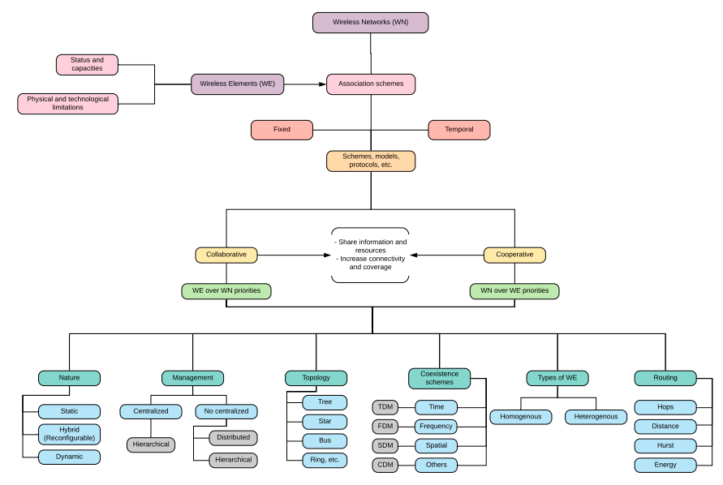
Figure 4: Concepts and aspects of Wireless Communication Networks [4].

Figure 4 shows the network architecture with all sensors organized by wireless technology. ZIGBEE nodes form a mesh network with a coordinator. LORA nodes communicate directly with the gateway. BLE nodes work as beacons with a scanner that forwards data via LORA. All data converges at the gateway and is sent to the cloud platform.

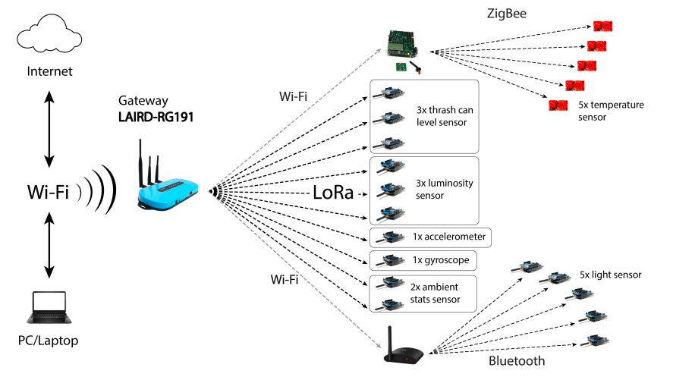
Figure 5: Network sensors under each technology [4].

Figure 5 Shows a representative scheme of the sensors according to the wireless technology and their respective application is presented. Coordinating nodes are observed that will serve as a bridge between three of the studied technologies: WIFI, ZigBee, and Bluetooth Low Energy (BLE).

What Protocols Did They Test?
This table present the four protocols they compared:
Table 1:Specifications of the studied wireless technologies[4].
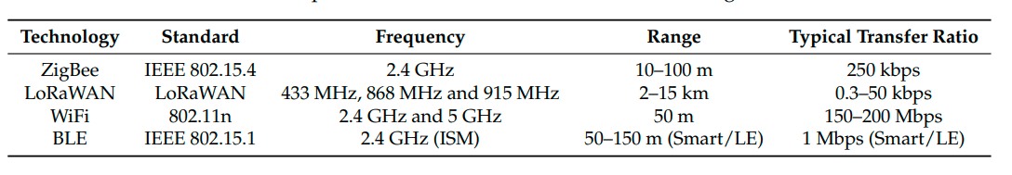

Collaborative vs. Cooperative – What is the Difference?
The networks are based on schemes, models, and protocols that establish the technology, transmission agreements, architecture, and management. This way, we can describe the association schemes according their functions. Two classes of schemes can be distinguished.
Collaborative scheme. It consists of sharing resources and functions only if the WE has availability and does not jeopardize its operation, WE priorities are over Wireless Network (WN) priorities.
Cooperative scheme. Its scheme is defined to share assigned resources and perform specific functions for all the elements in the networks. All the tasks must be performed through strict rules or protocols, i.e., WN priorities are over WE priorities. In this case there are strong commitments among their members.

Results Under the Cooperative Scheme
Tables 2 and 3 show the results of the different protocols under the cooperative and collaborative schemes. The metrics used together with the results should be analyzed together as they affect each other. When a node connects to the network the route discovery stage starts, in the case of ZigBee the gateway must assign an ID to the connected node. On the other hand, some protocols send control messages so that other nodes respond them, and in this way, the new node creates its neighbor tables and depending of the configuration also creates its routing tables. Hence, the more percentage of disconnected nodes the discovery process will occur more times.
Table 2:Nodes under the cooperative scheme[4].
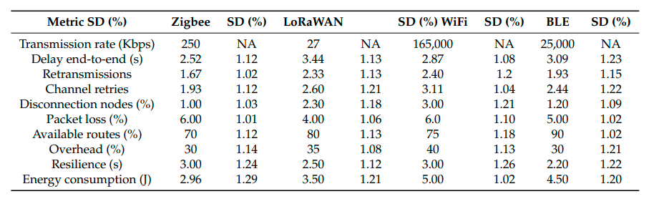
Table 3:Nodes under the collaborative scheme[4].
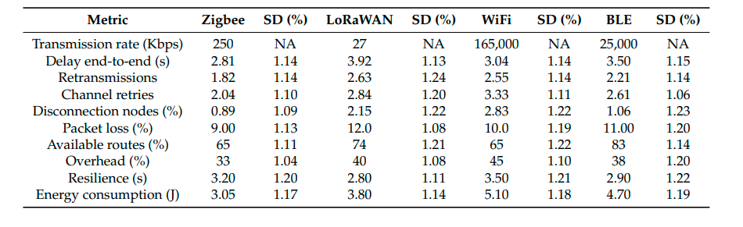
Although Del-Valle-Soto et al. provide a very strong experimental comparison of energy consumption in Wireless Sensor Networks (WSN), a major limitation is the age of the communication standards used. Since the study was published in 2020, it does not account for the recent energy-efficiency improvements found in 5G or the latest Wi-Fi 6/7 IOT protocols. Additionally, the experimental setup was conducted in a controlled environment, which may not accurately reflect the signal interference and physical "noise" found in a large, multi-building smart university campus. The study also focuses almost entirely on energy and packet delivery, neglecting the security overhead incorporating strong encryption often increases energy consumption, a trade-off that this paper does not deeply explore.

Comparison and Conclusions
The literature reviewed in this chapter covers four main areas related to the proposed Smart University Mobile Application Integrated with IOT-Based Campus Services. The reviewed studies include IOT adoption in higher education, QR-code-based attendance management, IOT-based smart parking systems, and wireless sensor network communication for smart campus environments. These studies provide the theoretical and technical foundation for the proposed project because they support the main services of the system: smart attendance, smart parking, navigation, guest/search assistance, and IOT-based communication.
Table 4 : Comparison of Studies.
Study | Focus Area | Methodology | Key Contribution | Limitations
Del-Valle-Soto et al. (2020) | Wireless sensor networks and IOT communication protocols | Experimental performance comparison using ZigBee, LoRaWAN, Wi-Fi, and BLE under cooperative and collaborative schemes | Compared different wireless communication technologies and showed how sensor networks can support IOT-based smart campus services | Focuses mainly on communication performance and energy consumption; does not provide a complete smart university mobile application
Mircea et al. (2025) | Internet of Things in higher education | Systematic literature review | Explained how IOT, cloud services, and smart applications can improve university operations and resource management | General study; does not provide detailed implementation of a complete mobile application with multiple campus services
AlAla’anzy et al. (2025) | IOT-based smart parking system | IOT and fog-computing architecture evaluated through simulation and a university parking case study | Proposed a real-time smart parking system that reduces latency, improves parking availability monitoring, and helps drivers find available parking spaces more efficiently | More complex than this project because it uses cameras, fog nodes, cloud servers
Rohann et al. (2026) | QR-code-based attendance management | QR-code-based authentication system | Proposed QR-code authentication to reduce manual attendance problems, improve attendance accuracy, and lower hardware cost | QR codes may be shared between students depends on mobile device
Therefore, there is a need for a Smart University Mobile Application capable of integrating attendance management, parking monitoring, campus navigation, and guest assistance services within a unified platform. Such integration can improve operational efficiency, simplify access to university services.
This project addresses this gap by proposing a Smart University Mobile Application that combines four key services: Smart Attendance using QR codes, Smart Parking, Smart Navigation, and Guest & Search services. The proposed platform utilizes IOT devices, cloud services, and mobile technologies to provide a centralized and scalable solution for modern university environments.

Discussion and Conclusion
The reviewed studies show that smart university systems depend on several connected technologies. Mircea et al. (2025) provide a general background on how IOT can support higher education services, including smart classrooms, smart assessment, and smart campus management. This supports the general direction of the proposed project because the Smart University Mobile Application also depends on IOT devices, cloud services, and digital interfaces to improve campus operations.
Rohann et al. (2026) focus on QR-code-based attendance management. This study is directly related to the Smart Attendance service in the proposed project because both systems aim to replace manual attendance with QR-code authentication. The main lesson from this study is that QR-code attendance can reduce time, improve record organization, and avoid the cost of fingerprint hardware. However, QR-code systems require extra validation to reduce fake attendance, such as session-based QR codes, short expiry time, student login verification, and scan-time recording.
AlAla’anzy et al. (2025) focus on IOT-based smart parking. Their study is relevant because parking congestion is one of the main problems addressed by the proposed project. The paper shows that real-time parking availability can reduce the time wasted searching for parking and improve parking space usage. The paper uses a more complex architecture based on cameras, fog nodes, proxy servers, and cloud computing, while the proposed project uses a simpler prototype based on ESP32 and ultrasonic or IR sensors. However, both systems share the same objective: providing real-time parking availability to users.
Del-Valle-Soto et al. (2020) support the communication side of IOT-based smart campus systems. Their study compares different wireless communication technologies such as ZigBee, LORAWAN, Wi-Fi, and BLE. This is useful for the proposed project because IOT services depend on reliable communication between sensors, microcontrollers, databases, and mobile applications. Although the study does not focus on attendance, parking, navigation, or guest search directly, it supports the technical background needed for IOT data transmission.
The main research gap found in the reviewed literature is that most studies focus on one service or one technical area only. For example, Rohann et al. focus mainly on attendance, while AlAla’anzy et al. focus mainly on parking, and Del-Valle-Soto et al. focus on wireless communication. These studies do not provide one centralized mobile application that combines several smart university services together.
The proposed project fills this gap by designing a Smart University Mobile Application that integrates four services into one platform: QR-code-based Smart Attendance, IOT-based Smart Parking, Smart Navigation, and Guest/Search Assistance. The system connects the mobile application, cloud database, dashboard, and IOT devices to provide a practical smart campus solution. Therefore, the main contribution of this project is not inventing QR-code attendance or IOT parking separately, but integrating multiple smart campus services into one centralized mobile application that improves university service accessibility, efficiency.
Based on this review, the proposed project is justified because it combines several smart university services into one mobile platform. The next chapter presents the design of the proposed system, including the system architecture, QR-code attendance workflow, smart parking design, navigation service, guest/search service, and database structure.

Project Design
This chapter presents the design of the proposed Smart University Mobile Application. The chapter explains the overall system structure, smart service integration, communication workflow, database design, and the proposed mobile application services developed to improve university operations and user experience.
The proposed system integrates IOT and the Four services into one centralized architecture. The system focuses on solving four major problems inside the university environment: Fake attendance during lectures, parking difficulties for students and teachers, navigation difficulty to find the location of university buildings, classrooms, and offices, no visitor services to search about building, class and offices.
To solve these problems, four smart services were designed: (Smart Attendance System using QR-Code, Smart Parking System, Smart Navigation System, Guest and Search System).
The proposed architecture improves communication efficiency, resource management and campus automation.
Based on the research gaps identified in Chapter 2, this design integrates smart university services within a unified mobile application supported by IOT devices, cloud technologies, and intelligent service modules.
This chapter is organized as follows: Section 3.1 provides a system overview; Section 3.2 describes the four smart services in detail, including hardware components for each; Section 3.3 lists all system components; Section 3.4 explains the system workflow; Section 3.5 discusses design considerations; and Section 3.6 provides a chapter summary.

System overview
The proposed system is a Smart University platform that integrates multiple campus services into a centralized mobile application. The system aims to improve efficiency, reduce operational complexity, and enhance the guidance for students, staff, and visitors.
The mobile application serves as the main interface for all users. Students, instructors, staff, and visitors access the four smart services (attendance, parking, navigation, and guest search) through this single mobile app. A separate web-based dashboard is provided for administrators and instructors to monitor campus activities in real time.
The system collects real-time information from different smart devices distributed across the university campus. The collected data is transmitted through the university communication network to centralized cloud services for storage and processing. The processed information is then delivered to administrators, instructors, students, and visitors through mobile applications and monitoring dashboards.
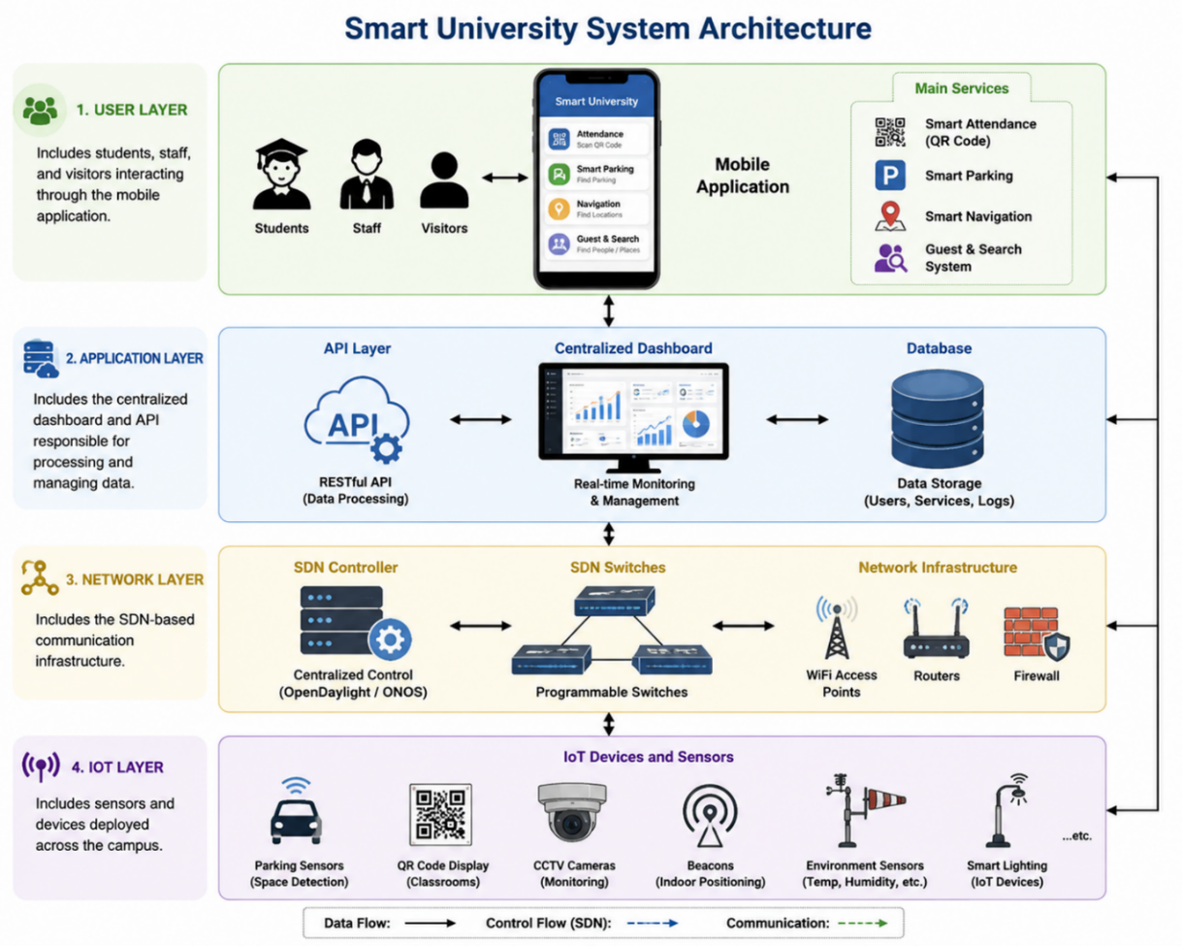
Figure 6: Smart University System Architectures.

Figure 6 shows the system Architectures of Smart University. The system follows a layered architecture composed of four main layers:
- User Layer: includes students, staff, and visitors interacting through the mobile application.
- Application Layer: includes the centralized dashboard and API responsible for processing and managing data.
- Network Layer: includes Wi-Fi, Bluetooth, Internet connectivity, and communication services that support data exchange between devices and cloud services.
- IOT Layer: includes sensors and devices deployed across the campus.

Smart Services Design
The system integrates several smart services into a unified platform accessible mobile application. These services are divided into four categories:
- Smart Attendance System
- Smart Parking System
- Smart Navigation System
- Guest and Search System

Smart Attendance System (QR-Code Based)
The Smart Attendance System was designed to automate student attendance recording using QR-code technology and mobile applications. Traditional attendance methods such as manual signatures and paper-based attendance sheets were considered inefficient because they consume lecture time, increase human errors, and allow attendance manipulation.
The platform was designed based on common problems identified during interviews conducted with students and instructors. The interviews highlighted issues related to time consumption during manual attendance procedures and difficulties in maintaining accurate attendance records.
Several attendance solutions were evaluated before selecting the QR-code approach. Traditional paper attendance sheets are simple to implement but are time-consuming and prone to manipulation. RFID cards provide faster attendance recording but require dedicated card readers and can still be misused if cards are shared among students. Biometric systems, including fingerprint and facial recognition technologies, offer strong identity verification; however, they introduce higher implementation costs, privacy concerns, maintenance requirements, and hardware dependencies. Mobile GPS-based attendance systems were also considered, but indoor location accuracy is often insufficient for classroom-level verification.
After comparing these alternatives, QR-code technology was selected because it provides faster attendance registration, lower implementation cost, easier deployment, and higher scalability for university environments.
At the beginning of each lecture, the instructor activates the attendance session using a QR-code attendance device connected to the centralized system. The system generates a dynamic QR code displayed inside the classroom. Students scan the generated QR code using their smartphone cameras through the university mobile application.
At the end of the lecture, the instructor closes the attendance session, and the system automatically generates a detailed attendance report containing student attendance information and timestamps. The generated report is directly sent to the instructor’s mobile device or dashboard.
In addition to instructors, the system includes an administrative management dashboard accessible by authorized university staff such as floor supervisors and academic administrators. Through this dashboard, administrators can manage classrooms, update room allocations, modify lecture schedules, monitor attendance activities, and generate reports. Any updates performed through the dashboard are synchronized automatically with the mobile application and the centralized database.
To improve security and reliability, several advanced features were added to the proposed attendance system. Dynamic QR-code regeneration was selected to prevent students from sharing screenshots of the QR code. consider important for improving identity confirmation and reducing fake attendance attempts.
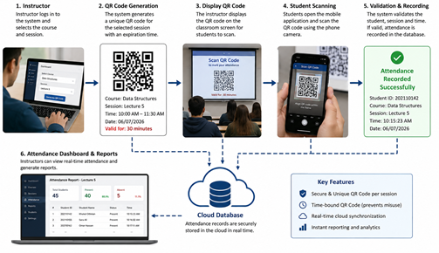
Figure 7: Proposed Smart Attendance System using QR code technology [6].

Figure 7 shows the workflow of the proposed Smart Attendance System using QR-code technology. The attendance process starts when the instructor activates the attendance session through the QR-code attendance device. The system then generates a dynamic QR code displayed inside the classroom. Students scan the QR code using their smartphones through the university mobile application. The attendance data is transmitted through the university network to the centralized cloud server, where attendance records are stored and processed. At the end of the lecture, the instructor closes the attendance session, and the system automatically generates and sends the attendance report to the instructor dashboard or mobile device.
To control late attendance registration, the instructor can configure a predefined attendance window through the system dashboard. Once the specified time expires, the QR code automatically becomes invalid and no additional attendance submissions are accepted. This feature helps enforce attendance policies and reduces unauthorized late registrations.
Components used: QR-code attendance device, Mobile application, Wi-Fi communication, Cloud database,
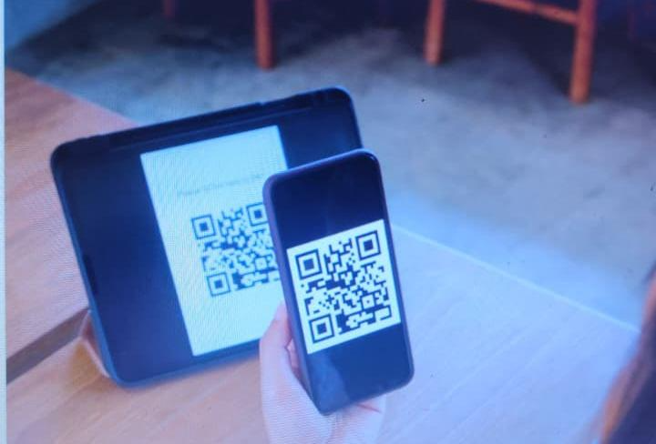
Figure 8: QR-Code Attendance Device.

Figure 8 shows that the QR-Code attendance device is responsible for generating and displaying dynamic QR codes during lecture sessions. The device communicates directly with the centralized server to update attendance records in real time.
has developed an attendance tracking software that includes a native mobile app allowing students to check into class by scanning a QR code.
This service provides several advantages for universities: Reduces manual attendance workload, Saves classroom time, Improves attendance accuracy and reliability, Prevents fake attendance attempts, Supports centralized attendance monitoring, Enhances digital transformation inside the university, Provides automated report generation and analytics.
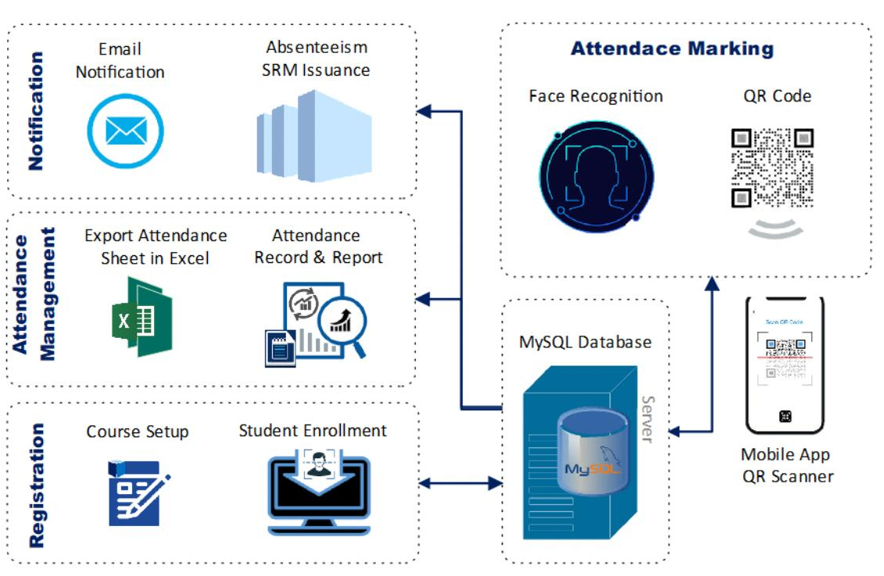
Figure 9: Smart Attendance Architecture [7].

Figure 9 presents the architecture of the proposed Smart Attendance System. The architecture consists of several interconnected components including the QR-code attendance device, student smartphones, Wi-Fi network infrastructure, centralized cloud server, database system, and instructor dashboard. The QR-code device generates dynamic attendance codes during lecture sessions, while students use mobile devices to scan the QR code and register attendance. The instructor can monitor attendance records and receive automatic reports through the dashboard or mobile application.
In the current project, the attendance system mainly relies on software-based verification mechanisms such as dynamic QR-code generation, attendance time restrictions, and database validation.

Smart Parking System
Interview metrics indicated that students lose an average of 15 to 20 minutes daily searching for parking, leading to localized campus traffic and chronic lateness. To resolve this concrete field issue, the Smart Parking architectural layout displays real-time IOT sensor telemetry on the mobile UI.
The platform was designed to reduce traffic congestion and improve parking management inside the university campus.
The proposed system uses IOT parking sensors connected to cloud services and mobile application interfaces. Parking sensors monitor parking occupancy and transmit real-time information to the centralized cloud database. Users can access parking availability information through the mobile application before entering parking areas.
The proposed parking system improves: Parking organization, Parking accessibility and Parking Allocation.
The current phase focuses on parking architecture design and workflow planning rather than full hardware deployment. Traditional parking management approaches were considered inefficient because drivers spend unnecessary time searching for available parking spaces.
IOT-based parking sensors were selected because they provide real-time parking monitoring and automated parking space detection. The system detects parking occupancy status and updates parking availability information through the mobile application.

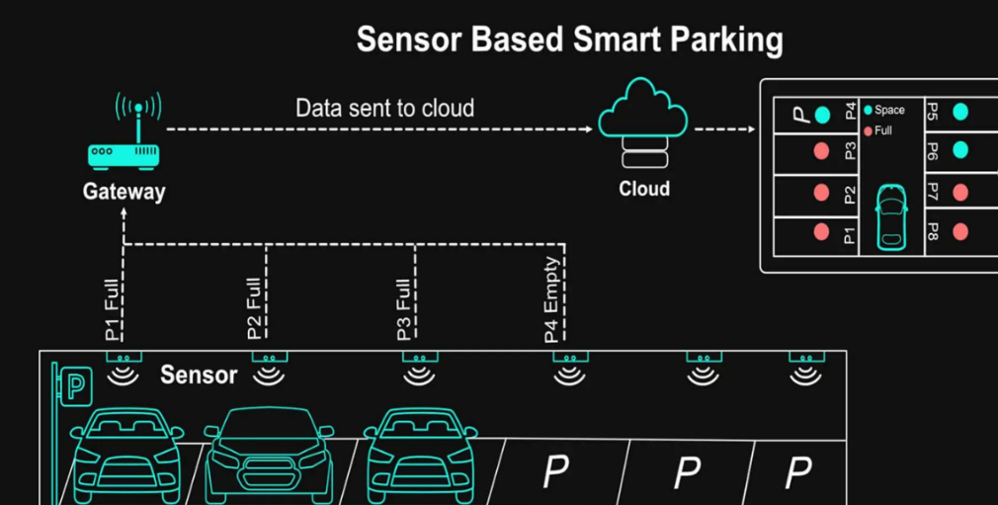
Figure 10: Smart parking Architecture [8].

Figure 10 illustrates the proposed architecture of the Smart Parking System used inside the university campus. The architecture integrates IOT parking sensors, cloud services, mobile application interfaces, and centralized communication infrastructure to support real-time parking monitoring.
Parking sensors detect parking occupancy status and transmit collected information to the cloud database through wireless communication services. The mobile application displays parking availability information and helps users locate available parking spaces efficiently.
The proposed architecture improves parking organization, communication efficiency, and overall user experience within the smart university environment.
Hardware components of prototype smart parking system:
Ultrasonic parking sensors, ESP32 Controllers, Mobile application, Cloud database.

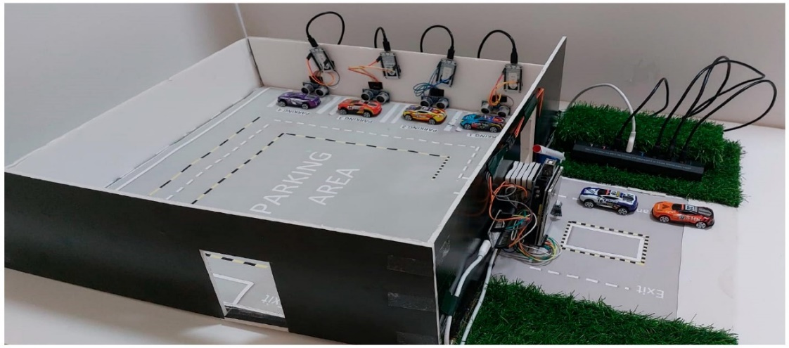
Figure 11: Proposed prototype of smart parking sensors

The developed prototype operates according to the following workflow:
Ultrasonic sensors continuously monitor parking occupancy. The Sensor data is transmitted to the ESP32 controller. The ESP32 processes parking information locally.
The collected data is transmitted through the IOT gateway, the centralized cloud server stores and analyses parking information.
Real-time parking availability is displayed through the mobile application and dashboard.
The proposed service prototype provides several advantages: Real-time parking monitoring, Reduced traffic congestion, faster parking allocation, intelligent parking management, centralized monitoring, improved user experience scalable IOT integration.
Applied Detection Condition:
To improve detection reliability, the parking system uses a validation condition before confirming slot occupancy. In the basic implementation, the ultrasonic reading must remain below a predefined threshold for a short continuous period before the slot is marked as occupied. In the improved design, two ultrasonic sensors can be assigned to each slot, and the slot is considered occupied only when both sensors detect the presence of a vehicle. This condition helps avoid false readings caused by pedestrians, animals, or temporary obstacles.

Smart Navigation System
The Smart Navigation System was designed to assist students and visitors in locating university buildings, classrooms, laboratories, and administrative offices efficiently. Large university campuses may create navigation difficulties for first-year students and visitors unfamiliar with campus facilities. The proposed navigation service combines GPS technology for outdoor navigation. Users can search for destinations through the mobile application and receive navigation guidance across the university campus. The designed service improves accessibility, reduces navigation confusion, and supports efficient movement inside the smart university environment.

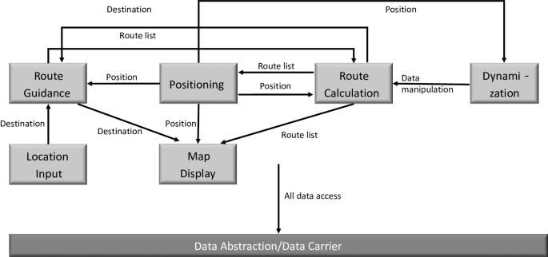
Figure 12: Smart Navigation System Architecture

Figure 12 illustrates the architecture of the proposed Smart Navigation System The system integrates GPS technology, Bluetooth beacons, mobile applications, cloud servers, Mobile Application to provide intelligent navigation services for students, staff, and visitors.
The role of each one is the following form:
GPS Module provides outdoor positioning and navigation between campus buildings.
Bluetooth Beacons provide indoor positioning where GPS signals are unreliable.
Mobile Application: receives user requests and displays navigation instructions.
Cloud Server: stores maps, building information, and navigation data.
while GPS technology supports outdoor navigation across the campus. The mobile application communicates with the centralized cloud server.
The proposed architecture improves navigation efficiency, reduces user confusion, and enhances accessibility inside the university campus.
Components used: GPS positioning, Bluetooth beacons, Mobile application, Cloud server.
Advantages of the Smart Navigation System: Reduces time wasted searching for buildings, Improves accessibility, Supports outdoor navigation, Helps visitors locate offices and classrooms, Provides intelligent route recommendations.

Guest and Search System
The Guest and Search System was designed to simplify visitor management and information searching inside the university campus.
Traditional information desks were considered inefficient because they require continuous human support and may create delays for visitors.
The designed service assists visitors and new students in locating university facilities and obtaining campus information.
Users can search for: Offices, Laboratories, Classrooms, administrative departments, Campus facilities. The proposed service improves visitor experience and reduces dependency on traditional information desks.
Interactive mobile applications were selected because they provide self-service information access and automated visitor assistance.
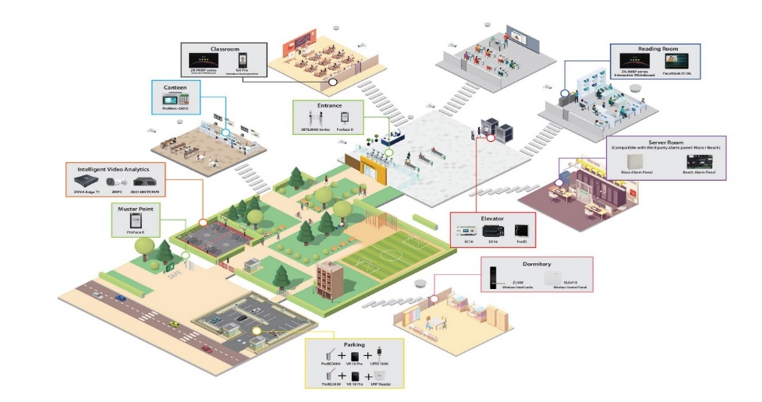
Figure 13: Guest and Search System Architecture [10].

The figure shown above illustrates the architecture of the proposed Guest and Search System used inside the smart university environment. The system integrates mobile applications, cloud databases to provide intelligent information and navigation services for visitors and university users.
Users interact with the system mobile applications to search for classrooms, departments, laboratories, instructors, and administrative offices. The search requests are transmitted through to the centralized cloud server.

System Components and Design Decisions
The proposed system integrates multiple hardware and software technologies to provide intelligent smart campus services. Several hardware platforms were analysed during the design process. ESP32 controllers were selected because they provide flexible IOT integration, low cost, and efficient local processing capabilities.
MQTT communication protocol was selected because several components of the proposed system, particularly the parking sensors and IOT devices, continuously exchange small amounts of data. Compared with HTTP, MQTT requires lower bandwidth, consumes fewer resources, and supports near real-time communication, making it more suitable for smart campus environments. instead of HTTP communication because MQTT provides lightweight communication suitable for IOT environments and real-time data transmission, IOT integration, and rapid system prototyping. Cloud databases were selected because they support centralized storage, remote access, scalability, and data backup.

Database Design
The proposed Smart University Mobile Application uses a cloud-based database to manage attendance records, parking information, navigation services, and user accounts efficiently.
The database supports communication between mobile applications, cloud services, and smart campus services through centralized data management and real-time synchronization. The current phase of the project focuses mainly on conceptual database planning and prototype modeling as part of the overall system design. The proposed system uses a centralized relational database model to manage all academic, administrative, operational, and service-related information generated by the smart campus environment. The database acts as the core component responsible for connecting all services together, including attendance management, parking monitoring, navigation services, and guest assistance functionalities. The database architecture was selected because it provides several operational advantages including: real-time data, improved data consistency, simplified administration, efficient service integration and easier maintenance procedures.
The database continuously receives and processes information generated by: mobile applications, IOT devices, parking sensors, attendance systems, navigation requests, and administrative dashboards.
The proposed database structure supports future scalability and allows additional smart services to be integrated into the system without major modifications to the existing architecture.

Mobile Application Design
The mobile application is the main interface of the proposed smart university system. It allows students, guests, and administrators to access the university services from one platform. The application will be designed using Flutter because it supports cross-platform mobile development and allows the creation of an organized and interactive user interface.
The mobile application is designed to include several services: smart attendance using QR code and face verification, smart parking, campus navigation, guest service, search service, and notifications. These services are accessed through a home dashboard after the user logs in or continues as a guest. Each service is connected to Firebase, which is used as the backend database for storing and retrieving data.

User Roles and Access Levels
The mobile application is designed with different access levels based on the user role. Each user type can access only the services related to their responsibilities. Students can use the application to scan QR codes for attendance, check parking availability, navigate inside the campus, search for university services, and receive notifications. Teachers can create QR attendance sessions, monitor attendance records, and send class-related notifications. Guests can access only public services such as campus navigation, search, parking availability, and public announcements without logging in as students. Admin users have the highest level of access, allowing them to manage users, services, campus locations, notifications, and system data. The all in formation shows in the following table
Table 5:User Roles and Access Levels.
User Type | Access in the Mobile Application
Student | Login, scan QR attendance, verify attendance using device and face verification, view parking availability, use campus navigation, search services, and receive notifications
Teacher | Login, create QR attendance sessions, monitor student attendance, view attendance records for assigned classes, and send class-related notifications
Guest
  View campus map, search buildings and services, view parking availability, and read public notifications
Admin | Manage users, manage teachers and students, create or edit campus locations, manage services, monitor parking data, create announcements, and control system settings

This role-based access design improves system security and organization because each user can only access the functions needed for their role. For example, a guest cannot access attendance records, a student cannot create attendance sessions, and only teachers or admins can manage attendance-related data.

Mobile Application Screens
The application design follows a simple dashboard structure. After login, the user is directed to the home screen where all available services are displayed as cards or buttons. Each card opens a specific service screen. This design makes the application easy to use and allows the system services to be organized in one mobile platform.
Table 6:Mobile Application Screens.
Screen | Design Purpose
Login Screen | Allows students and admins to sign in
Home Screen
  Displays the main service dashboard
Attendance Screen | Allows students to scan QR code and verify attendance
Parking Screen
  Shows available and occupied parking slots
Navigation Screen
  Displays the digital campus map
Search Screen | Allows users to search for buildings and services

Service Integration Design
In this section we show how the system integrate with the services together showed in the following figure

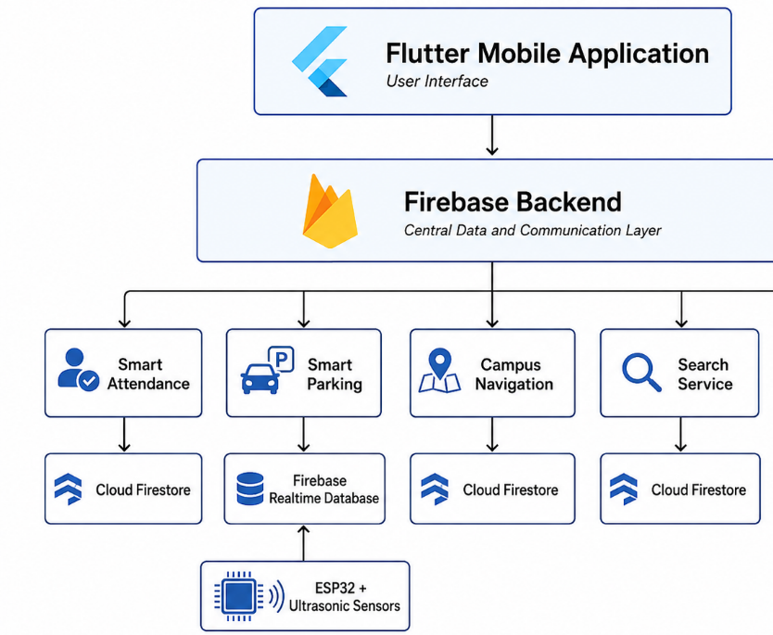
Figure 14: System integration.
The Flutter mobile application is connected to Firebase as the central backend. Each service uses Firebase according to its function. The attendance service stores attendance sessions and records in Cloud Firestore. The parking service reads live parking data from Firebase Realtime Database, which receives data from the ESP32 and ultrasonic sensors. The navigation and search services read campus location and service information from Cloud Firestore. The notification service reads announcements added by the admin and displays them to the user as pop-up messages.

Conclusion
This chapter presented the design of the proposed Smart University system. The chapter explained the system architecture and described the four smart services developed to solve university operational problems.
The Smart Attendance System solves fake attendance problems using dynamic QR-code verification. The Smart Parking System improves parking management using IOT sensors. The Smart Navigation System helps users locate campus facilities using GPS and Bluetooth beacons. The Guest and Search System improves visitor support and information accessibility.
The next chapter explains the methodology used to design, develop, and how the process proposed system.

Methodology
This chapter explains the methodology used to design and evaluate the proposed Smart University system. It describes the research design, system development process, prototype testing strategy, implementation procedure, constraints, and analysis methods used in the project.
The proposed methodology focuses on integrating IOT devices, and Mobile application one centralized smart campus architecture.
The mobile application is the primary component of this architecture. All users (students, instructors, staff, and visitors) interact with the smart campus through the mobile app. The success of the project is measured by how well the mobile application delivers the four smart services to end users.
This chapter is organized as follows: Section 4.1 explains the research design and methodology used in the study. Section 4.2 discusses the system requirements and design strategy. Section 4.3 identifies the main project constraints. Section 4.4 presents possible solutions to the identified university problems. Section 4.5 explains the process used to select the best solution architecture. Section 4.6 presents the instruments and tools used throughout the project. Section 4.7 discusses the implementation procedure and project timeline. Finally, Section 4.8 explains the analysis techniques used for evaluating system performance.
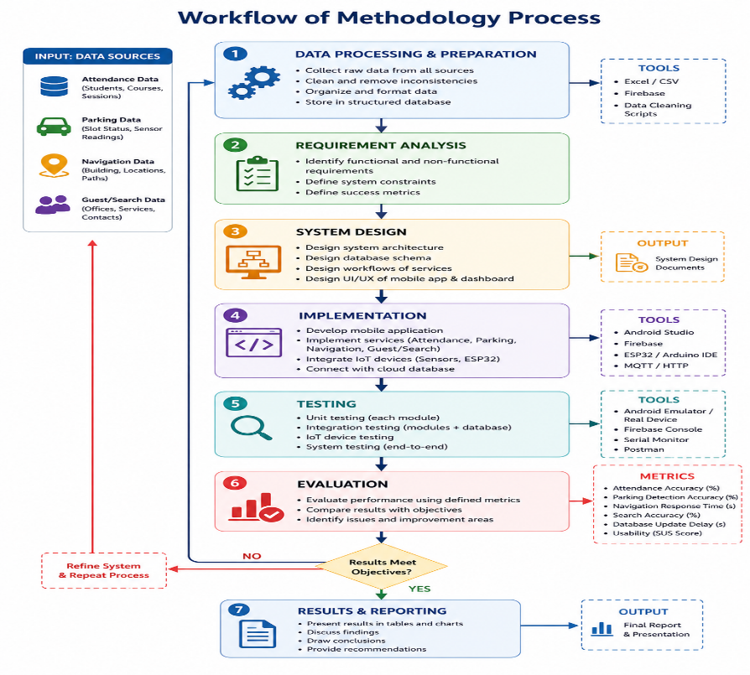
Figure 15: Proposed Workflow of Methodology.

Figure 14 shows the overall workflow of the proposed Smart University Platform. The workflow begins with identifying the major operational problems faced inside university campuses, including fake attendance during lectures, parking congestion, navigation difficulties, and limited visitor guidance services. After defining the problem statement, the system requirements are analysed to determine the functional and non-functional requirements necessary for the implementation of the proposed platform.
The methodology workflow begins with identifying university operational problems and defining system requirements. The system architecture and database are then designed, followed by mobile application development and IOT integration. After implementation, datasets are collected and processed for system testing and performance evaluation.

Research Design
The proposed project follows a design-oriented methodology focused on developing a conceptual prototype for a Smart University Mobile Application.
The methodology includes problem identification, requirement analysis, system architecture design, database planning, workflow development, and mobile application prototype design.
The current phase of the project focuses mainly on conceptual system planning and smart service integration rather than full system implementation or hardware deployment.
The mobile application is the primary component of this architecture. All users (students, instructors, staff, and visitors) interact with the smart campus through the mobile app. The success of the project is measured by how well the mobile application delivers the four smart services to end users.
This research design is suitable because the project deals with real operational problems inside a university campus. The problem of fake attendance cannot be solved only by discussion; it requires a secure attendance workflow, validation rules, and testing. The problem of parking cannot be solved only by suggesting more parking areas; it requires real-time sensing, data transmission, and guidance to available spaces. The problem of campus navigation cannot be solved only by placing signs; it requires a digital route system that supports both indoor and outdoor movement. Similarly, the problem of guest and search services requires a searchable digital information system that helps users find buildings, offices, classrooms, and persons more quickly.
Recent smart campus studies show that IOT projects must consider several design challenges during the development stage, including interoperability, scalability, data storage, processing, visualization, and integration of devices from different vendors. Other studies also show that smart campuses can be treated as small-scale smart cities where low-cost sensors and open data protocols can support real-time monitoring of people, parking occupancy, and environmental information. Based on this direction, the research design in this project follows a structured flow that begins with problem identification and ends with performance analysis.
Table 7: Methodology Stage.
Methodology Stage | Purpose in This Project | Expected Output
Problem identification | Understand the real campus problems related to attendance, parking, navigation, and visitor search | Clear problem requirements and service needs
Literature review support | The reviewed studies include IOT adoption in higher education, QR-code-based attendance management, IOT-based smart parking systems, and wireless sensor network communication for smart campus environments. | Technical foundation for the proposed solution
System design | Convert the problem requirements into a four-layer architecture and four smart services | Architecture diagrams, workflow models, and component selection
Service modelling | Define how each smart service collects, transmits, processes, and presents data | Service workflow and data-flow logic
Simulation and testing | Test the communication and service behavior using selected tools | Measurable network and service performance indicators
Evaluation and analysis | Compare the results with project objectives and selected performance metrics | Final interpretation of the proposed architecture effectiveness

Problem Requirements
The proposed methodology begins with a clear definition of the requirements because the quality of the final design depends on how accurately the problem is understood. In this project, the requirements were derived from the problem statement, Chapter 3 project design, and the expected needs of the university environment. The system is designed to solve three main categories of problems: unreliable attendance, inefficient parking management, and difficulty in locating university resources. These problems are solved through four services.
Table 8:Problem Requirements.
 | Service | Main Problem | Functional Requirement | Non-Functional Requirement
 | Smart Attendance using QR-code | Fake attendance and slow manual attendance | Generate dynamic QR code, validate student scan, store timestamp, produce report | Security, privacy, speed, reliability, low cost
 | Smart Parking | Teachers and students cannot quickly find parking | Detect occupied/free spaces, update availability, guide users | Real-time response, scalability, low latency, accuracy
 | Smart Navigation | New students and visitors waste time finding buildings or persons | Provide GPS outdoor routes | Usability, accessibility, route accuracy, fast response
Guest and Search Service |  | Visitors cannot easily find rooms, offices, departments, or staff | Provide searchable database, mobile interface. |  | Ease of use, accurate results, data privacy, integration.
The first requirement is to reduce fake attendance. In traditional attendance systems, students may sign for absent classmates, share attendance codes, or give their identity information to other students. Manual attendance also wastes lecture time and creates extra work for instructors. Therefore, the Smart Attendance service must generate a dynamic QR code for each lecture session, record the student identity, capture the scan time, validate the attendance session, and allow the instructor to receive an automatic report. proximity checking to reduce proxy attendance.
The second requirement is to reduce the time wasted by students and teachers when searching for parking. During busy periods, drivers may enter the campus without knowing whether parking spaces are available. This creates congestion, delay, frustration, fuel waste, and unnecessary movement inside the campus. Smart parking literature confirms that conventional parking systems are inefficient because drivers often search manually without accurate real-time information, which increases congestion and travel time. Therefore, the Smart Parking service must detect parking space availability, update the central server in real time, and show users available spaces through the mobile application or dashboard.
The third requirement is to support new students, visitors, and even existing users who may not know the location of classrooms, laboratories, buildings, offices, or specific staff members. This is important because large campuses are difficult to understand, especially during the first weeks of study, examination periods, or public events. Outdoor navigation can be supported by GPS, to estimate user location and provide indoor services. Therefore, the Smart Navigation service must combine outdoor GPS guidance with positioning.
The fourth requirement is to provide a Guest and Search Service. Visitors and students should be able to search for a department, office, instructor, classroom, laboratory, or service without asking many people or waiting at an information desk. The system should support smart search, natural language queries, and automatic redirection to the navigation service. This service is important because smart campus systems should not only collect data; they should also make campus information easier to access.
These requirements lead to several system-level needs. The architecture must be scalable enough to handle many users and sensors. It must also be reliable because attendance, parking, and navigation are time-sensitive services. The system must protect user privacy because it may process student identities, attendance records, location data, and staff information. It must also be cost-aware because universities need solutions that can be implemented gradually without requiring very expensive infrastructure.

Mobile Application Development Methodology
The mobile application is the main interface of the proposed smart university system. It allows students, teachers, guests, and administrators to access the system services from one platform. The mobile application will be developed using Flutter, while Firebase will be used as the backend platform to manage authentication, database storage, real-time updates, and file storage.
The methodology of developing the mobile application follows a step-by-step process.
First, the Flutter development environment will be prepared. Then, the mobile application screens will be designed and connected together. After that, Firebase will be configured and connected to the Flutter application. Finally, each service will be integrated with the backend and tested separately before combining all services into the final system.

Flutter Development Environment
Flutter will be used to develop the mobile application frontend. It is selected because it allows the development of mobile applications using a single codebase and provides a flexible user interface design. Dart will be used as the programming language for Flutter in the following table
Table 9: Flutter development tools.
Tools | Purpose
Flutter SDK | Used to build the mobile application
Dart
  Programming language used with Flutter
Visual Studio Code | Code editor for writing the application code
Android Studio | Provides Android SDK and emulator
Flutter Extension | Helps run and debug Flutter projects in VS Code
Dart Extension
  Supports Dart programming in VS Code

Firebase Connection Method
Firebase will be used as the backend of the mobile application. The Flutter application will be connected to Firebase using Flutter Fire configuration. Firebase will manage user login, data storage Firebase is used as the backend platform for the proposed smart university mobile application. It provides several cloud-based services that help connect the Flutter mobile application with the system database and the smart parking hardware. In this project, Firebase will be responsible for user authentication, data storage, real-time parking updates, image storage, and notification management.
Firebase is selected because it is suitable for mobile applications, easy to connect with Flutter, supports real-time data synchronization, and reduces the need to build a separate backend server from the beginning. This makes it appropriate for the proposed prototype because the project requires communication between the mobile application, the database, and the ESP32 parking system.
The Firebase services used in the project are:
Firebase Service | Purpose in the Project
Firebase Authentication | Manage login for students, teachers, and admins
Cloud Firestore
  Store users, attendance records, campus locations, search data, and notifications
Firebase Realtime Database | Store live parking status from ESP32
Firebase Storage | Store images such as student face images, profile images, and campus map images
Firebase Cloud Messaging | Future use for push notifications

Dataset Collection and Preparation
The proposed smart university architecture depends on multiple datasets generated from simulated IOT devices, mobile applications, communication logs, and centralized cloud databases.
The datasets are used for: attendance verification, parking prediction, behavioural analysis, communication monitoring.

Smart Attendance Dataset
The Smart Attendance System generates datasets containing in the following table7
Table 10:Dataset about Smart Attendance.
Data Field | Description
Student ID | Unique student identifier
Lecturer ID | Lecture session
Timestamp | Attendance time
Device ID | Mobile device information
QR Session ID | Dynamic QR code identifier
Authentication Status | Verification result
Location Data | Attendance location

Smart Parking Dataset
The Smart Parking System generates datasets including in the following Table 8
Table 11:Dataset of Smart Parking System.
Data Field | Description
Parking Slot ID | Parking identifier
Occupancy Status | Occupied or available
Timestamp | Detection time
Parking Duration | Vehicle parking duration
Traffic Density | Parking area traffic load

Navigation Dataset
The navigation system generates datasets in the following table containing:
Table 12: Dataset for Navigation System.
Data Field | Description
User Location | Current user coordinates
Destination | Requested location
Route Distance | Navigation path length
Travel Time | Estimated navigation duration
Building Information | Campus building data

Guest and Search Dataset
The Guest and Search dataset stores visitor search requests and campus information queries in the following table.
Table 13:Dataset of Guest and Search System.
Data Field | Description
Visitor ID | Visitor Identifier
Request Department | Target Department
Search Request | Search Keyword
Destination Location | Request Location

Project Constraints
Every engineering project is affected by constraints, and these constraints must be considered before selecting the final solution. In this project, the most important constraints are related to cost, time, network performance, privacy, security, scalability, accuracy, and deployment complexity. These constraints do not prevent the project from being implemented, but they shape the way the methodology is designed.
Table 14: Constraint.
Constraint | Impact on the Project | Methodological Response
Cost | Limits the use of expensive biometric systems and full-scale deployment | Use QR codes, ESP32, ultrasonic sensors, BLE beacons, and simulation tools
Time | Limits full campus implementation during FYP1 | Focus on design, simulation, prototype workflow, and evaluation plan
Privacy | Attendance and location data are sensitive | Minimize data collection, use access control, and store only required records
Security | Fake attendance and unauthorized access may occur | Use dynamic QR codes, session tokens, timestamp validation, and optional face/proximity checks
Accuracy | Sensor and positioning errors may reduce trust | Calibrate sensors, validate readings, and measure error rates
Scalability | System may need to cover more buildings later | Use layered architecture, modular APIs, cloud database.

Proposing Possible Solutions
Before selecting the final methodology, three possible solutions were considered. Each solution was evaluated according to public welfare, safety, social acceptance, economic feasibility, environmental impact, cultural suitability, and technical performance. This step is important because an engineering project should not select a technology only because it is modern. The selected technology must actually fit the university environment and solve the real problem.

Solution 1: Mobile Application Integrated with Four services
The possible solution is to design an integrated smart campus architecture that combines the four services under one platform. In this solution, IOT devices collect data, the mobile application dashboard presents the results to users. The attendance system, parking system, navigation system, and guest search system are connected through a shared application layer and centralized database.
This solution has higher design complexity than the first two solutions, but it is more suitable for the project objectives. It reduces fake attendance through dynamic QR-code validation. It improves parking by using real-time sensor data and smart allocation. It supports navigation by combining GPS. It improves visitor experience through smart search mobile access. It also fits the literature because modern smart campus systems require interoperability, scalability, visualization, and integrated processing.

Selecting the Best Solution
The selected solution: Mobile Application Integrated with Four services . This solution is selected because it is the only one that directly solves the four service problems while also matching the project title and objectives. It provides a unified platform rather than separate tools, and it allows the researcher to evaluate the network and service performance through measurable indicators.
The selected high-level design follows the four-layer architecture described in Chapter 3. At the bottom, the IOT layer includes the QR-code attendance device, student smartphones, ultrasonic parking sensors, ESP32 controllers, smart cameras, GPS. These devices collect raw data from the campus environment. The network layer includes Wi-Fi access points, Bluetooth Low Energy BLE communication, IOT gateways, MQTT messaging, and Mobile Application. The application layer includes APIs, databases, dashboards, and data visualization. The user layer includes instructors, students, teachers, staff, visitors, and administrators.
For the Smart Attendance System, the instructor opens an attendance session through the dashboard or QR-code device. The system generates a short-lived QR code linked to the lecture ID, classroom ID, instructor ID, and timestamp. Students scan the QR code using the university mobile application. The application sends the student ID, session token, scan time, and optional location/proximity data to the server. The server validates the request and records the attendance. If suspicious behaviour is detected, such as repeated scans from different locations or scanning outside the allowed time, the record is flagged for instructor review. Optional face verification may be used for higher security classes.
For the Smart Parking System, each parking space or parking zone is monitored using ultrasonic sensors and/or smart cameras. The sensor reading is processed by an ESP32 or local gateway. The gateway sends only the parking status, such as occupied or available, to the server using MQTT. The mobile application displays real-time parking availability and recommends a suitable parking area for students or teachers.
For the Smart Navigation System, the mobile application uses GPS for outdoor routes between campus gates, parking areas, and buildings. When the user enters a building, the system estimates the user position and provides route guidance to classrooms, laboratories, offices, or service areas. Since BLE signals may be affected by walls and environmental changes, the methodology includes calibration and repeated testing for positioning accuracy.
For the Guest and Search Service, users access information through a mobile application. A visitor can search using keywords such as “admission office,” “Dean office” “Lab 2,” or “Networking department.” The system searches the centralized database and returns the most relevant result. If the user needs directions, the result is passed to the navigation service to generate a route.

Instruments
The instruments used in this study are the tools, devices, software platforms, and measurement methods required to design and evaluate the proposed system. Since this is an engineering project, the instruments are not limited to questionnaires or interviews. They include simulation tools, IOT devices, software libraries, databases, and prototype components.
The First group is the IOT and prototype devices. The Smart Parking prototype uses ultrasonic sensors to detect the presence of vehicles, ESP32 controllers to read sensor values, and Wi-Fi/MQTT communication to send data to the server. The Smart Attendance service uses a QR-code display device, student smartphones, and a server-side session validation module. The Smart Navigation service uses GPS for outdoor positioning. The Guest and Search service uses a mobile application connected to a central database.
The Second group is the software and development instruments. A cloud or local database will store attendance records, parking status, building information, staff directory data, and service logs. A dashboard will be used to visualize system status, service usage, and performance metrics.
The Third group is the measurement instruments. These are the indicators used to evaluate whether the system works well. For the attendance service, the metrics include attendance recording time, validation success rate, suspicious scan detection, and report generation time. For parking, the metrics include detection accuracy, update delay, and parking recommendation response time. For navigation, the metrics include route generation time, positioning error, and successful destination guidance. For the Guest and Search service, the metrics include search response time, result relevance, and user task completion time.
Table 15: Tools and Instrument.
Tool | Purpose
Android Studio | Mobile app
Firebase | Database
Figma | UI Design
Arduino IDE | Esp32 microcontroller

The mobile application is developed using Android Studio with Java/Kotlin. Figma is used for designing the user interface. Firebase Real time database is used for backend data storage and synchronization. These tools together enable the development of a fully functional smart university mobile application.

Procedure and Timeline
Table 16:Timeline & Procedure.
Tasks | Achieved | Not Achieved
Topic Selection | ✅
Literature Review | ✅
Background | ✅
Problem Statement | ✅
Objectives | ✅
Proposed Methodology | ✅
First Presentation | ✅
Implementation of the Methodology |  | ✅
Performance Evaluation |  | ✅
SWOT Analysis |  | ✅
Report Completion |  | ✅
Final Presentation |  | ✅

Analysis
The proposed system will be evaluated using a combination of quantitative simulation metrics, prototype performance measurements, and comparative analysis against the baseline results found in the reviewed literature. This multi-method approach ensures that the evaluation is both rigorous and practically meaningful.
For attendance system evaluation, the prototype will be tested across a minimum of three simulated lecture sessions. For each session, the following metrics will be recorded: the average time for a student to complete the attendance scan, the percentage of valid scans correctly accepted, and the percentage of invalid scans (simulated using a screenshot of a previous QR code) correctly rejected, and the time required to generate the attendance report. Accuracy will be expressed as a percentage and compared against the manual attendance baseline.
For parking system evaluation, the ultrasonic sensor prototype will be tested against a set of ground-truth observations in which parking spaces are physically occupied or empty, and sensor readings are compared. Detection accuracy will be calculated as the proportion of correctly identified states across a minimum of fifty test observations. The average delay between a physical state change (a vehicle entering or leaving a space) and the corresponding update appearing in the mobile application will also be measured.
All quantitative results will be presented in tables and charts in Chapter 5 (Results and Discussions). For each objective stated in Chapter 1, the results will be discussed with reference to the literature to explain whether the proposed architecture performed as expected, where it exceeded or fell short of baseline performance values, and what factors may have contributed to any observed deviations. This discussion will form the basis for the conclusions and recommendations presented in Chapter 5.

Conclusion
This chapter presented the methodology adopted for developing and evaluating the proposed Smart University Mobile Application Integrated with IOT-Based Campus Services. The methodology was based on system requirement analysis, mobile application prototyping, database planning, IOT parking prototype testing, and service evaluation.
The chapter identified the main problems addressed by the project, including manual attendance procedures, parking congestion, difficulty in campus navigation, and limited guest assistance. Based on these problems, the proposed system was divided into four main services: QR-code-based Smart Attendance, IOT-based Smart Parking, Smart Navigation, and Guest/Search Assistance.
The methodology also explained the datasets required for each service, including attendance records, parking slot status, navigation location data, and guest/search information. In addition, the chapter discussed the project constraints related to time, budget, hardware availability, internet connection, and system accuracy.
The selected solution is a unified mobile application supported by a cloud database, dashboard interfaces, and IOT devices. The attendance service depends on QR-code scanning through the mobile application, while the parking service depends on ESP32 controllers and ultrasonic or IR sensors to detect available and occupied parking spaces. The navigation and guest/search services depend on structured campus location data stored in the database.
Finally, the evaluation of the proposed system will focus on QR-code attendance accuracy, parking detection accuracy, database update delay, navigation/search response, and mobile application usability. This methodology provides a clear plan for implementing and testing the proposed smart university system in the next phase of the project.

Results and Discussions
To be continued in FYP2

Project Management

Schedule of Tasks and Gantt Chart
This Gantt chart shown in Figure 6.1, outlines the planned progression for the initial stages of my Final Year Project (FYP), To ensure the structured and timely execution of the research, a comprehensive 15-week timeline was established for the Final Year Project I (FYP1) phase during the Spring 2026 semester.

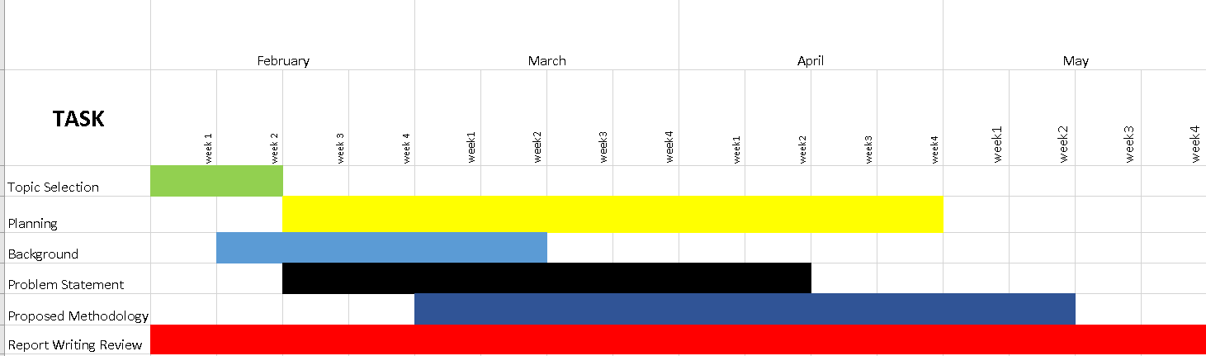
Figure 16: Gantt Chart .

SWOT Analysis
To be continued in FYP2

Expected Budget
To be continued in FYP2

Students’ Responsibilities and Contribution
To be continued in FYP2

Conclusions and Future Works
To be continued in FYP2.

References
[1] Mircea, M., Stoica, M., & Ghilic-Micu, B. (2021). Investigating the impact of the internet of things in higher education environment. Ieee Access, 9, 33396-33409.
[2] Rohann, S. (2026). Optimized QR Code-Based Authentication System for Attendance Management. Acta Pedagogia Asiana, 5(SI), 140-150.
[3] Ala’anzy, M.A., Abilakim, A., Zhanuzak, R. et al. Real time smart parking system based on IoT and fog computing evaluated through a practical case study. Sci Rep 15, 33483 (2025). https://doi.org/10.1038/s41598-025-15507-6
[4] C. Del-Valle-Soto, L. J. Valdivia, R. Velazquez, L. Rizo-Dominguez, and J.-C. Lopez-Pimentel, "Smart Campus: An Experimental Performance Comparison of Collaborative and Cooperative Schemes for Wireless Sensor Network," Energies, vol. 12, no. 16, p. 3135, Aug. 2019.
[5] Min-Allah, N., & Alrashed, S. (2020). Smart Campus—A Sketch. Sustainable Cities and Society, 59, 102231.
[6] Beyond Innovations & Technologies Limited. (2023). Case study: Deployment of student attendance system using QR codes at Chittagong Independent University.
[7] Siew, E. S. K., Chong, Z. Y., Sze, S. N., & Hardi, R. (2023). Streamlining attendance management in education: A web-based system combining facial recognition and QR code technology. Journal of Advanced Research in Applied Sciences and Engineering Technology, *33*(2), 198-208.
[8] Khanna, A., & Anand, R. (2016). IoT based smart parking system. In 2016 International Conference on Internet of Things and Applications (IOTA) (pp. 266-270). IEEE.
[9] PTS Mobile. (2021). ClearStream Bluetooth beacon tracking starter kit.
[10] Genetec Inc. (2024). Smart university solution all-in-one web-based security management solution .

Appendices
    - Requirements Gathering and Field Interviews
The development of a user-centric and infrastructure-aware system requires a thorough investigation into the actual operational constraints present within the contemporary university environment. Rather than relying on purely theoretical assumptions, the system architecture and technical specifications engineered in this project (as detailed in Chapters 3 and 4) were directly justified by field data.
To achieve this, structured stakeholder interviews were conducted during the initial phase of Final Year Project I (FYP 1). The target evaluation groups comprised a sample size of fifty (50) active university students and fifteen (15) academic faculty members. This empirical requirements-gathering phase served a dual purpose: first, to establish a qualitative baseline for the primary bottlenecks impeding campus efficiency, and second, to systematically map out the functional requirements for the proposed integrated mobile application services.
The following sections document the exact question blueprints distributed to both test groups, followed by a cross-examination analysis that highlights the shared problems identified across the campus infrastructure.

A.1 Student & Teachers Interview Questionnaire (11 Detailed Questions)
- On average, how many minutes do you lose daily searching for an available parking slot inside the campus during peak hours?
- Does the stress of finding a parking space cause you to arrive late or miss the beginning of important lectures?
- Do traditional, manual attendance tracking methods (like paper sheets or verbal roll calls) disrupt your focus or cause delays at the sharp start of your class?
- Have you ever experienced instances where your attendance was marked incorrectly due to human error in traditional registry sheets?
- Have you ever struggled to find a specific instructor’s office, a temporary examination hall, or a laboratory during your first semesters or multi-department events?
- Does the lack of reliable real-time indoor positioning or maps inside multi-story campus buildings increase your orientation anxiety?
- How much time do you typically spend waiting in queues or waiting for email responses to get answers for basic academic questions (e.g., schedules, general rules)?
- Do you find the current university channels for obtaining generic administrative guidelines slow or inefficient?
- Would having all campus services (Attendance, Parking, Navigation, Chatbot) centralized inside a single mobile application interface improve your daily student experience?
- What percentage of your lecture duration is consumed by administrative tasks like manual attendance tracking?
- Is proxy attendance (students signing for absent classmates) a noticeable problem in your larger classrooms?

